Abernethy Memorial United Methodist Church
Sixth Sunday after Epiphany
11:00 A.M. February 17, 2019

Nursery is available for children birth through age 2.

ENTRANCE

WELCOME AND ANNOUNCEMENTS
PASSING OF PEACE
PRELUDE
CHORAL CALL Holy, Holy

*OPENING PRAYER (respond on the bold print)

Lord, we have gathered in your presence to worship and glorify you. We seek to bless you with our praise, and hope that we might receive a blessing in return. Yet we recognize that in your Kingdom blessings sometimes come in unexpected ways. Grant us grace to see the truth and to respond to you accordingly. Amen.

*OPENING HYMN Rejoice, the Lord is King UMH 715

PROCLAMATION AND RESPONSE

*SCRIPTURE LESSON Luke 6:17-26

*RESPONSE TO THE WORD
The Word of God for the people of God; thanks be to God.

* LITANY OF CONFESSION AND ASSURANCE (respond on bold print)
Blessed are we when we let go of possessions
for the kingdom of God unfolds in open places.
Woe to us when we gather into barns
for soon this life will be over.
Blessed are we who know the ache of hunger
for the empty places in body and soul are the fertile soil for new growth.
Woe to us who fill our lives to capacity
for we fail to recognize what is missing.
Blessed are we who know sorrow
for the ache of love lost is witness to the seed planted.
Woe to us who have yet to know the pain of grief
for the fullness of love is woven with sorrow.
Blessed are we who know scorn
for the rejection of humans keeps us mindful of that beyond.
Woe to us who depend on the approval of others
for to dance with the Spirit appears foolish.
Blessed are we who live in the harmony of life in the Spirit,
for we will recognize abundance. Amen.

*SONG OF RESPONSE Seek Ye First UMH 405

CHILDREN’S MESSAGE

LIL’ BLUE BUCKETS
Little blue buckets, up the aisle they come, gathering change we bring, gathering change we bring. Let's fill them up, let's fill them up, to feed those in need, to feed those in need. Let's do our best to help all those who come, seeking what we have to share with them. Little blue buckets, let's fill them up, for all those in Need.

*All children age 3 – Kindergarten are invited to participate in children’s worship*

SHARING OF JOYS AND CONCERNS
PASTORAL PRAYER
THE LORDS PRAYER UMH 895
GIVING OF OUR TITHES AND OFFERINGS
OFFERTORY
*DOXOLOGY UMH 95
*OFFERTORY PRAYER
ANTHEM Blest are They

MESSAGE Sermon on the Plain Pastor April

INVITATION TO CHRISTIAN DISCIPLESHIP

*HYMN OF DEDICATION Blessed Assurance UMH 369

SENDING FORTH

*DISMISSAL WITH BLESSING
*CHORAL BENEDICTION Amen Choir
*POSTLUDE
*Stand as you are able

The flowers are given to the Glory of God.
Cost for placing flowers in the Sanctuary is $40.00.

SECRETARY OFFICE HOURS Monday, Wednesday, Thursday 11 – 6

Weekly amount needed: $ 3,126.00
Weekly amount received: $ 2,322.00

Year To Date needed : $18,756.00
Year To Date received: $14,560.00

Yearly Budget Amount: $162,562.00
Yearly Budget Amount received: $ 14,560.00
Yearly Budget Amount needed: $147,992.00

Abernethy Memorial United Methodist Church
PO Box 127, Rutherford College, NC 28671
Phone: 828-879-8894 Fax:828-879-6141
Church E-mail:amumcrc@abernethymemorialumc.org
Pastor E-mail:aabernethy1@gmail.com

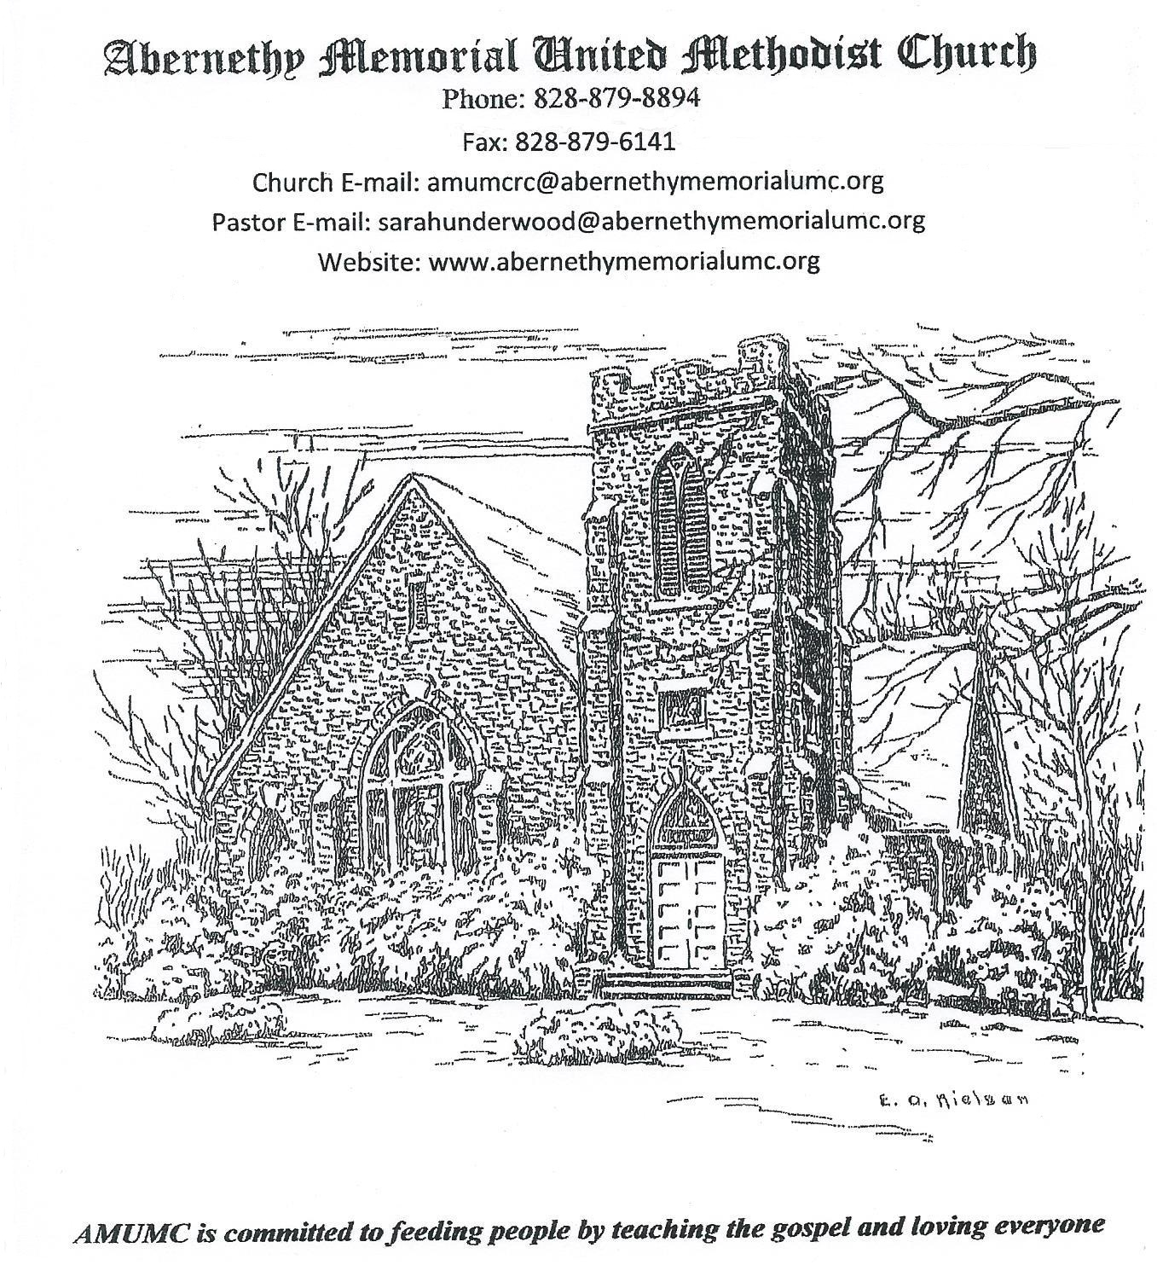
The purpose of AMUMC is to welcome all people to a safe community where we worship God, grow disciples for Christ, and share God’s unconditional love.

SERMON NOTES
SCRIPTURE: Luke 6:17-26
TITLE: Sermon on the Plain

ABERNETHY MEMORIAL STAFF

Rev. April Abernethy
Pastor

Sharon Blanton Sharon Blanton
Interim Choir Director Organist/ Pianist

Marie Lowdermilk Jamie Donnelly
Treasurer Custodian

Zachary Cagle
Secretary

PRAYER CONCERNS
CHURCH FAMILY
Richard Jensen, Jerry & Linda Hedrick, Ivey Jr. & Carolyn Griffin, Zach Coffey and Family, Peggy Griffin, Nola Ruppard, Frankie O’Toole, Leon Pons, Confirmation Class,
Danny Glenn
HOMEBOUND & NURSING HOME
Dean Lankford, Wagg Cannon, Tommy Elmore, Connie Hunphries, Lillian Mauney
FRIENDS/FAMILY of CHURCH FAMILY
Barry Downer, Vicky Hicks, Edith Bolick, Ben Hemmings, Byron Hemmings, Tim Ennis,
Whitney Coffey, Mitzi Lane, Will Zimmerman, P.O. Wilson, John Lankford,
Candace Donnelly Pearson, Bill Chambers, Leonard Hawkins, Stephanie Shuffler, Carl Derreberry, Aurora, Nancy Whisnant, Anthony Locke, Cathy Wooten, Family of Derell Pruette, Family of Richard Whisnant, Family of David Abee, Corbit Looper, Ruth Fricsell, Jerry Bowens, Danner Family
OTHER CONCERNS
Violence and unrest in Nation and World, Wright’s Pantry Families, Terrorism victims, Domestic Violence Victims, Students and school personnel, Disaster Relief victims & workers, Our nation, leaders, and government workers, special session of General Conference

We are attempting to update our prayer list. Names added to the prayer list will remain on for 2 – 3 weeks unless the person has an extended illness or need.
To facilitate the updating of our prayer list and to aid our prayer ministers, please fill out a prayer request card which is located in the back of the pews, and place it in the offering plate. Thank you for your cooperation.

LAY READER: Yates Jensen NEXT SUNDAY: Ivy Beth Abernethy
NURSERY WORKER: OPEN NEXT SUNDAY: OPEN
CHILDREN’S CHURCH : Tammy & Sherry NEXT SUNDAY: Jim & Ann Jacumin
COUNTERS: Melinda & Kim NEXT SUNDAY: Marty, Ben, Jackie
GREETERS: Melinda NEXT SUNDAY: OPEN
ACOLYTE: OPEN NEXT SUNDAY: OPEN
USHERS:
This Sunday: John Sigmon, Griffin Stephens, John Sherrill, OPEN
Next Sunday: Jonathan Crisp, Gary Donnelly, Jamie Donnelly, Samuel Crisp

ANNOUNCMENTS
The best way to reach Pastor April is to call or text her cell phone at 980-295-9792. Please do not use the parsonage phone to leave a message as she sometimes misses calls on it. She really wants to receive your calls, so please use her cell phone number. Thank you so much!

TREE OF LIFE. The cost is $50 per leaf. Please fill out the order forms on the front pew to place a leaf on the tree in honor or memory of someone.

NUTS have been reduced. Prices are on the boxes. Please place money in offering plate mark envelope NUTS.

UPCOMING
- Sunday, February 17: 3:15 pm Acolyte Training
4 pm Confirmation
6 pm Finance Meeting
7 pm Ad Council
- Wednesday. February 20: Information Due for Bulletin
11:00 AM Women Prayer Group
7 pm Choir
- Friday February, 22: 4:30 pm Seniors to Sims BBQ
- Saturday February 23: 5 pm XYZ at Crosslink
- Sunday, February 24:
- Wednesday. February 27: Information Due for Bulletin
11:00 AM Women Prayer Group
7 pm Choir
- Saturday, March 2: 7 am – Noon Wrights Pantry
- Tuesday, March 5: 6 pm Shrove Tuesday Pancake Supper
- Wednesday, March 6: 6 pm Ash Wednesday Worship

The choir has started rehearsing for our Easter Cantata! Please join us on Wednesdays at 7:00 if interested in singing with us!

Acolyte Training will be TODAY at 3:15 in the sanctuary. This is for all current acolytes and those interested in learning how to serve in this ministry.

Senior Adults will leave on Friday, Feb. 22 at 4:30 pm to go to Sim’s BBQ. The all you can eat buffet costs $11.75 plus tax.

Tuesday March 5, Shrove Tuesday Pancake supper 6 pm

Ash Wednesday Worship March 6 6 pm

Remember to save your hard plastic bottle caps and jar lids for the buddy bench project. You can dump them into a box that will be provided in the classroom just off the narthex.

Please be aware that ONLY bottle caps and jar lids are acceptable items. Here’s a list to make it easier:

CLEAN CAPS ONLY from:
(NOT THE BOTTLE, JUG, TUBE, or CONTAINER)
medicine bottle (caps only)
milk jugs
detergent
hair spray
toothpaste
deodorant
drink bottles (soda, water, juice and sports drinks)
ointment tubes
shampoo/conditioner

also acceptable:
flip top (example ketchup)
spout caps (example mustard)
spray-paint can tops

LIDS ONLY from:
(AGAIN, NOT THE CONTAINER, ONLY THE LID)
mayonnaise
peanutbutter

NOT ACCEPTABLE: ANY AND ALL PLASTIC THAT IS NOT A CAP OR LID (example NO hairbrushes, NO pumps from lotion or soap containers, NO plastic pieces or parts…) If you have questions, you can email me : rblossom@charter.net or call me: 874-1974 (land-line with answering machine). I am old-school, also have no cell-service here, and I do not text, nor get on social media… Many thanks... :-) Rosie

